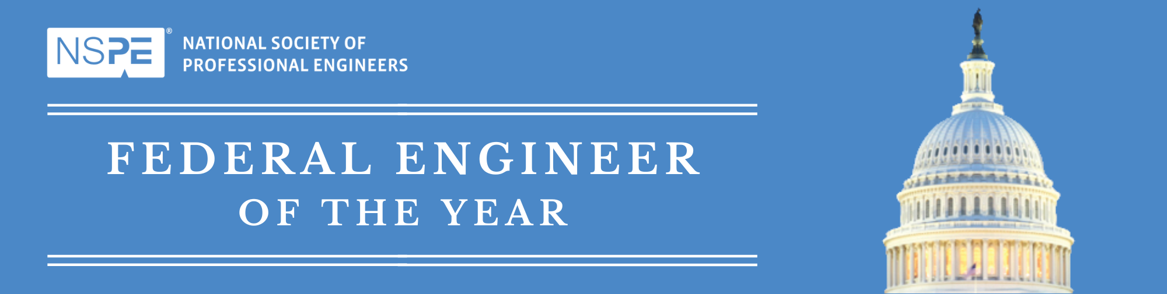

**Presenter Information**

**2025 Federal Engineer of the Year Award**

**February 21, 2025**

**National Press Club, Washington D.C.**

**Each agency/department winner will be presented with a plaque at the awards luncheon on February 21, 2025 at the National Press Club in Washington, D.C.**  The plaques will be presented by the NSPE president and a representative from the winner’s agency/department. Check-in for the event begins at 12:30 PM EST with lunch and ceremony beginning at 1:00 PM EST. The Agency presenter will accompany the agency winner on stage. This is a handshake, photo opportunity. There is no speaking role for the presenter.   
  
**You will need to purchase a lunch ticket for all agency attendees including the presenter and agency winner.**

**Agency/Department:**

**Agency/Department winner:**

**Presenter name:**

**Presenter Title:**

**Please return completed form by January 31, 2025 to:** [**peg@nspe.org**](mailto:peg@nspe.org)