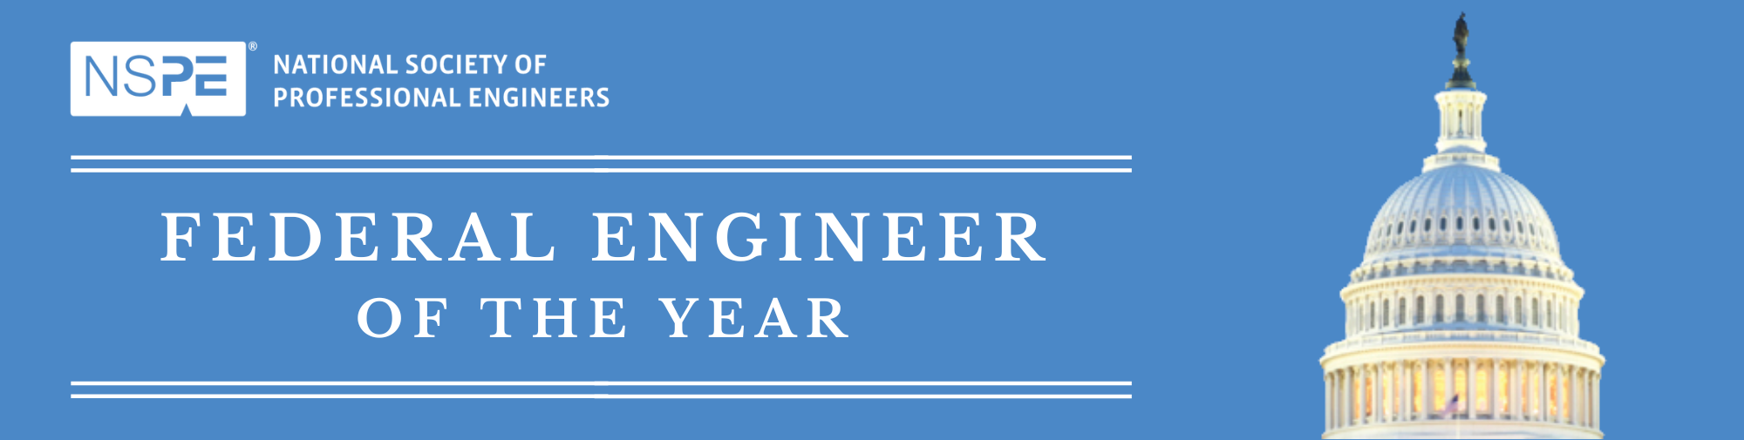  
 **FEYA POC/Agency Winner Checklist**

Please submit these items on or before deadline dates to: [peg@nspe.org](mailto:peg@nspe.org)

* **Logistics:** The ceremony will be held on Friday, **February 21, 2025**, at the National Press Club in Washington, D.C. Registration begins at 12:30PM. All agency winner plaques will be presented after lunch, followed by recognition of the Top Ten finalists. The 2025 NSPE Federal Engineer of the Year will then be honored. The ceremony will adjourn at 2:30PM. Attire for the luncheon is business suit or the military equivalent.
* **Event Tickets: Tickets are now available at:** [**www.nspe.org/FEYA**](http://www.nspe.org/FEYA)**. Tickets must be purchased by February 12, 2025.** There is no limit to the number of guests that may attend. If any of your luncheon attendees have dietary restrictions, please indicate that when you purchase the ticket.
* **Presenter Information Needed: Please complete the Presenter Form and return it to** [**peg@nspe.org**](mailto:peg@nspe.org) **by January 31, 2025.** Each agency is responsible for providing a representative to present the agency plaque to your winner. This person should be the recipient's supervisor or a high ranking official from your agency. Presenters are not required to speak, however, they are required to join the winner on stage to present the plaque.
* **Recognition Plaques:** NSPE has purchased plaques for each agency winner. We will use the information you provided on the plaque information form. Plaques will be shipped to NSPE and will be transported to the ceremony. NSPE will also provide the Founder's Medallion to be presented to the NSPE Federal Engineer of the Year.
* **Agency Winner Photos:** We will be showing a PowerPoint presentation of the agency winners before the ceremony. If you have not provided us with a portrait photo of your agency winner please do so immediately. In addition, if you have a photo of your winner at work that you can send that would be great. Send photos in JPG format to [peg@nspe.org](mailto:peg@nspe.org)Thank you in advance for your help!