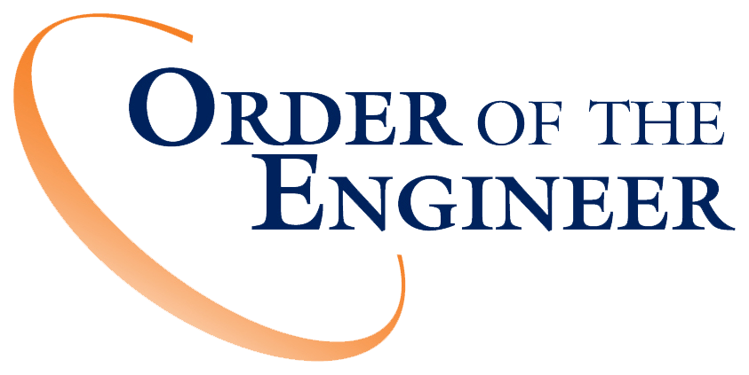



2017 Professional Engineers Conference (Event Name)
1:15-1:45 P.M. (Time)

Thursday July 20, 2017 (Date)

Hosted by the
National Society of Professional Engineers
NSPE World Headquarters, Link #220
(Hosting Entity/Link #)

Induction Ceremony Conducted By

David A. Janover, P.E.,F.NSPE, Link 080 (Speaker #1)
Erin Gates, P.E., Link 103 (Speaker #2)
Kenneth McGowan, P.E., F.NSPE, Link 016 (Speaker #3)



The Order of the Engineer is a solemn obligation to oneself to uphold devotion to the standards and the dignity of the engineering profession. It is an obligation to turn to practical use the principles of sciences and the means of technology…
to serve humanity by making the best use of Earth's precious wealth.

(Reminders as candidates and guests enter this is a solemn ceremony, certain parts require total silence, photos are allowed as long as proper respect is shown to all other participants and guests.)

WELCOME/START Ceremony ~ 1:15 PM

(Janover) (Speaker #1)
Good morning/afternoon/evening, and welcome to all. My name is David Janover, P.E., F.NSPE (Speaker #1) and I was inducted into the Order of the Engineer by Link 80, the New York State Society of Professional Engineers. (Link Name/Link #)

If Speaker #1 is an Order of the Engineer Governor:
It is my privilege, on behalf of the National Board of Governors of the Order of the Engineer, to preside and welcome you to this Order of the Engineer Ceremony.

If Speaker #1 is not an Order of the Engineer Governor:
It is my privilege, on behalf of the (State or Local Chapter of NSPE), to preside and welcome you to this Order of the Engineer Ceremony.

Other members of the Order who will be assisting in conducting this ceremony are my fellow colleagues, Erin Gates, P.E., (Speaker #2) who was inducted into the Order by Link 103, the University of Wyoming, (Link Name/Link #) and Kenneth McGowan, P.E., F. NSPE, (Speaker #3) who was inducted by Link 16, the Washington Society of Professional Engineers. (Link Name/Link #)

If presenting an Invocation (optional):
(Speaker #1): I would like to now call upon Invocation Speaker Name to present an Invocation.
(Invocation Speaker): Eternal God, Master of this strange and wonderful universe, we ask your guidance in this hour. We praise you for the riches of creation and for the resources you have placed in our hands for us to use as we think best. We are humbled by the size of the task. Lord, give us dedication and wisdom to meet our obligation as engineers. Strengthen us when the load seems heavier than we can bear; lift us up when things go wrong; and help us not to be weary in well doing. Under divine guidance, may we undertake seemingly impossible projects, and acquit ourselves with honor. We pray, today, that the obligation we take and the stainless steel ring we wear may be evidences of our vision and calling, and that this world may be a happier and better place because we choose to make it so, now and for years to come. Amen.
(Speaker #1): Thank you.
(Speaker #1): This morning/afternoon/evening, we will tell you about the History of the Order, the Purpose of the Order, and the Significance of the Ring. When we call the inductees forward, we ask that you bring your program with you. We will place the stainless steel ring on the little finger of your working hand, and you will publicly take the Obligation of an Engineer. Engineer Gates (Speaker #2) will now explain the History of the Order.

(Gates) (Speaker #2) HISTORY OF THE ORDER:
This ceremony presents an opportunity for us to take a pledge and to recall that the professional purpose of engineering involves the pursuit of a learned art in the spirit of public service. By following the acceptance of the Obligation, the individual engineer reinforces similar efforts of his or her peers, realizing that in unity there is strength.
Decades ago, our engineering counterparts in Canada had this same feeling. They believed that a need existed for the introduction of a spirit of brotherhood and cohesiveness among engineers. The Canadians believed that a good way to achieve this purpose would be to instill in engineers a consciousness of belonging to one another, to themselves as individuals, and to those whom they served.
Thus, what was done in 1926 in Canada, is what is now known as the "Ritual of the Calling of an Engineer." The words of the ritual were written by the English author, Rudyard Kipling, who had much depth of feeling for engineers as the builders of things intended to benefit mankind.
The Canadian ceremony is dignified, impressive, and includes the placing of a wrought iron ring on the small finger of the individual’s working hand, and then having them repeat in concert the words of Kipling. It is difficult to visualize any better symbolism than that of a ring, worn for all to see, and saying in effect, that here is an engineer dedicated to a publicly avowed obligation to the profession and to those it has served. In Ohio, the idea of similar maxims to those written by Kipling were well established and correspondence began in October 1953 between the Canadian Wardens, responsible for the administration of the Calling of an Engineer, and officers of the Ohio Society of Professional Engineers, with a view to possibly extending the Canadian ceremony to the United States.

Due to copyright and other conflicting factors, extension of the ritual into this Country was not possible. During 1966, a group of engineers in Ohio, with members of several engineering organizations, began to pursue the objective of what came to be called the "Order of the Engineer."
While the deliberations of this group were in progress, seniors of Fenn College of Engineering at Cleveland State University, counseled by Dean Burl Bush, designed and held a ring ceremony and reception on June 4, 1970. Each participant signed a creed and received a plain stainless steel ring placed on the small finger of his or her working hand. One hundred seventy engineering seniors and engineering faculty members took part in this first ceremony. Since then, the Order has grown to include tens of thousands of members inducted at Links (local chapters) established in nearly every State in the Union. Although patterned after the Canadian concept, the Order of the Engineer has differences that are distinctively associated with the United States of America. We ask that you accept with pride the meaning and purpose of the ceremony in which you are about to participate: to uphold the standards and integrity of the engineering profession.
Engineer McGowan (Speaker #3) will now tell us about the Purpose of the Order…
(McGowan) (Speaker #3):
PURPOSE OF THE ORDER:
The Order of the Engineer, to which you will soon belong, is an independent organization. The purpose is to foster a feeling of pride in and dedication to that profession which binds us together.
You are asked to accept with pride the meaning of the ceremony to which you are about to subscribe. The “Obligation” should be freely given and the responsibility gladly accepted. The Order is symbolized by the acceptance of an “Obligation” and the wearing of a stainless steel ring on the little finger of the working hand.
The Obligation is the formal statement of an engineer’s responsibilities to the public and to the profession. It is a creed similar to the oath attributed to Hippocrates that is commonly taken by medical graduates and which sets forth an ethical code. The Obligation likewise contains parts of the Canon of Ethics of major Engineering Societies.
Initiates, as they voluntarily accept it, pledge to uphold the standards and dignity of the engineering profession and to serve humanity by making the best use of Earth’s precious and limited resources. The “Obligation” is a composite of several creeds. It emphasizes the fact that we, as engineers, have certain obligations. It promotes honesty and integrity, and recognizes that today’s engineers are dependent on their predecessors for their skills.
I now call upon Engineer Janover (Speaker #1) to discuss the Significance of the Ring.

(Janover) (Speaker #1): I will now share some thoughts on the Significance of the Ring.
The ring, a symbol of pride, prestige, honor, and professionalism among all engineers in the United States, also serves as a reminder of our obligation to society.
The significance of what you are about to say and do might be expressed this way:
- I am an engineer
- I have an obligation to my profession
- My desire is to apply the golden rule, our Code of Ethics, to the practice of my profession
- My Obligation is the yardstick of my professionalism
- My professionalism means to me that I will never ask myself the question “how much do I get out of it?” but rather, I will ask “how much can I give?”

The symbol of your desire to serve the public is the engineer’s ring. The ring you will wear on the fifth finger of the working hand will say to all who see it ─ here is an engineer, possessed of a publicly avowed dedication to the profession and the public they serve. It is our symbol – wear it for all to see. The ring is a badge of recognition which will become known to all as the sign of a learned professional pledged to making the best use of Earth’s precious and limited resources.
As I call your names, I will ask each of the inductees to please come forward with your program, to receive your ring from Engineer McGowan (Speaker #3) who will place the ring on the little finger of your working hand. Then form a line to the side of the table. (or appropriate location)
List of Inductees: (call forth one at a time, and wait for each to receive their ring before calling the next inductee)
(Inductee #1)
(Inductee #2)
(Inductee #3)
(Inductee #4)
Your membership in the order is symbolized by the acceptance of an "Obligation" and the wearing of the stainless steel ring on the little finger of the working hand. There are no meetings other than this ceremony, and there are no dues.
We ask all current members of the Order of the Engineer to please stand and renew your Obligation. At this time, please turn to the Obligation of an Engineer in your Program.
Candidates, raise your right hand, and all standing, recite with me the "Obligation of an Engineer":
(Janover and Group) (Speaker #1 and Group):
I am an engineer. In my profession I take deep pride. To it I owe solemn obligations.
As an engineer, I pledge to practice integrity and fair dealing, tolerance and respect; and to uphold devotion to the standards and the dignity of my profession, conscious always that my skill carries with it the obligation to serve humanity by making the best use of Earth's precious wealth.
As an engineer, I shall participate in none but honest enterprises. When needed, my skill and knowledge shall be given without reservation for the public good. In the performance of duty and in fidelity to my profession, I shall give the utmost.
Congratulations! (Lead Applause)
(Audience may be seated, candidates remain standing)

We will now have a few words from Engineer Gates (Speaker #2) on Professionalism & Ethics…

(Gates) (Speaker #2) Professionalism & Ethics:
It means that I shall be guided by the highest standards of honesty and integrity and I at all times strive to serve the public interest. I shall not be influenced by conflicting interests. I shall accept personal responsibility for my professional activities. I shall give credit for engineering work to those to whom credit is due, and will recognize the proprietary interests of others. It is also a reminder of the value system I was brought up with. It is the refresher of the guiding principles that I must adhere to in my professional life.

To conclude our ceremony, I call upon Engineer Janover (Speaker #1).

(Janover) (Speaker #1):
As we conclude this Order of the Engineer ceremony, we welcome each of you to the privileges and the obligation of the Order of the Engineer. This Obligation means more than the right to practice the application of science for the betterment of humanity or the enjoyment of a generous fee. This Obligation means we are more than highly trained technicians. We must be engineering educators, as well, and must learn to apply our knowledge and teach others to seek and use our services.

This ring is a reminder of our calling. It symbolizes the strength and wholeness of life. In whatever avenue our profession leads, in creating a cleaner environment, designing a better bridge, devising a finer product, developing a safer community, there our talents should be applied; not for an hour, or a day, not for a year, but for life, on land, on the sea, in the air or the vast reaches of space.

This certificate is your creed. It bears your name and signature. It is your pact with your profession. Read it thoughtfully. Display it publicly. This is your ring. In times of anxiety, look on it and take courage. In times of honor, regard it with humility. Wear it proudly. God bless you, and may God bless America.

This concludes the ceremony – you may be seated.

(Lead Applause)

