Ceremony

NSPE Annual Meeting

Atlanta Marriott Marquis, Atlanta, GA

Thursday July 20, 2017
(Event Name, Location and Date/Time

Hosted by the
National Society of Professional Engineers

NSPE World Headquarters, Link 220
(Host Link and Link #)

Induction Ceremony Conducted By
David A. Janover, P.E., F.NSPE, Link 080 (Speaker #1)
Erin Gates, P.E., Link 103 (Speaker #2)
Kenneth McGowan, P.E., F.NSPE, Link 016 (Speaker #3)

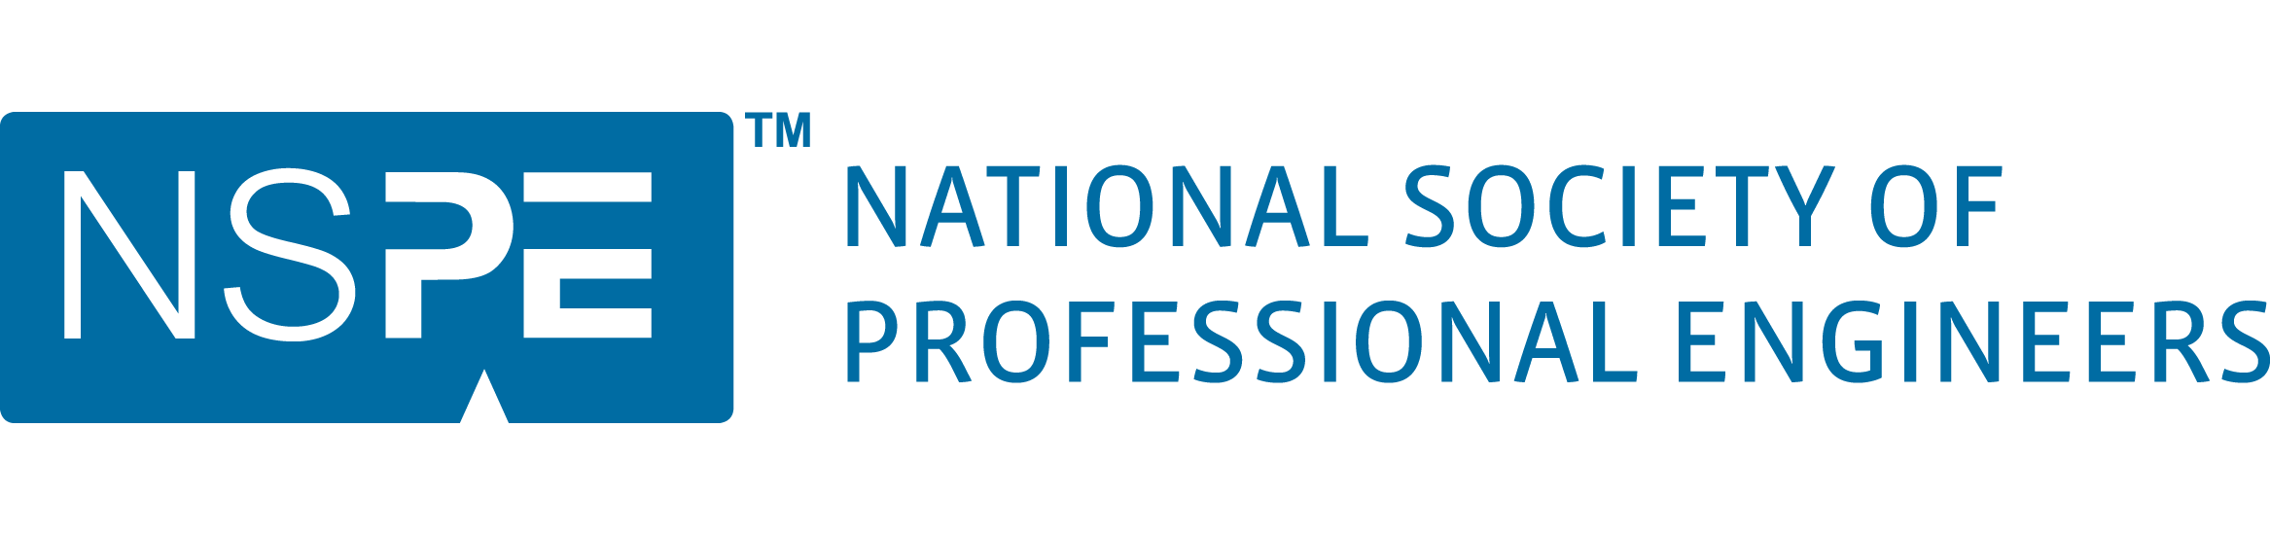
INSERT CEREMONY INFORMATION (University, Location, date, time)




INSERT CEREMONY INFO (HOST LINK, LOCATION, DATE/TIME)

INDUCTEES:
Candidate #1
Candidate #2
Candidate #3
Candidate #4
Etc.

INTEGRITY TOLERANCE RESPECT DEVOTION HONESTY

OBLIGATION OF AN ENGINEER

(Candidates read aloud)

I am an Engineer. In my profession, I take deep pride. To it, I owe solemn obligations.

As an Engineer, I pledge to practice integrity and fair dealing, tolerance and respect, and to uphold devotion to the standards and the dignity of my profession, conscious always that my skill carries with it the obligation to serve humanity by making the best use of Earth’s precious wealth.

As an Engineer, I shall participate in none but honest enterprises. When needed, my skill and knowledge shall be given without reservation for the public good. In the performance of duty and in fidelity to my profession, I shall give the utmost.

Induction Ceremony
National Society of Professional Engineers

NSPE World Headquarters, Link 220
Program

Welcome David Janover, P.E., F.NSPE
(Speaker #1)
Invocation Invocation Speaker

History of the Order Kenneth McGowan, P.E., F.NSPE
(Speaker #2)
Purpose of the Order Erin Gates, P.E.
(Speaker #3)
Significance of the Ring David Janover, P.E., F.NSPE
(Speaker #1)
Call of Inductees David Janover, P.E., F.NSPE
(Speaker #1)
Presentation of Ring Kenneth McGowan, P.E., F.NSPE
(Speaker #3)
Obligation of an David Janover, P.E., F.NSPE
Engineer (Speaker #1)
Professionalism & Ethics Erin Gates, P.E.
(Speaker #2)
Concluding Remarks David Janover, P.E., F.NSPE
(Speaker #1)

