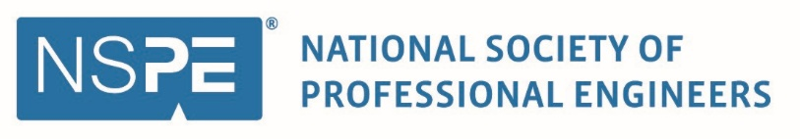

Sample Request for Attendance Letter to Employer

<DATE>
Dear <SUPERVISOR NAME>,
I am writing to seek your support for me to attend the Nationals Society of Professional Engineers annual conference, NSPECon26, in New York City, New York, August 5-7, 2026. Attending the conference will further develop my skills and knowledge and allow me to add even more value as an employee of <YOUR ORGANIZATION/COMPANY>. The conference is in-person which allows me to network face-to-face with professional engineers, innovators, and leaders across all industries and disciplines. By attending the educational sessions offered, I can also earn up to 10 professional development hours (PDHs) toward the continuing education requirements to maintain my PE license.
After reviewing the conference program, I identified sessions that will allow me to gain valuable insight and understanding about how I can help enhance and improve our current work environment. All presentations are conducted by industry experts and offer best practices for engineering professionals. Upon my return, I would welcome and appreciate the opportunity to share the knowledge learned from the following sessions:
<INSERT LIST OF SESSIONS YOU WANT TO ATTEND>
The total estimated cost associated with attending this conference is $<TOTAL ESTIMATED COST>. Attached is a detailed explanation of costs associated with my attendance.
Thank you for considering my attendance at NSPECon26. I look forward to maximizing my participation and developing a deeper understanding of the engineering industry and workplace. As the only national conference for licensed engineers, I plan to learn best practices, participate in networking opportunities, and create additional value through knowledge and resource sharing within <YOUR ORGANIZATION/COMPANY>. The conference program is available at www.nspecon.org. I look forward to your approval or welcome the opportunity to discuss this request more fully.

Sincerely,

<YOUR NAME>

